**SOLUTION 6:**

1. Create a Chat Application which uses Kafka as a streaming platform and consume the chat messages in the command prompt.

2. Create a Chat Application using C# Windows Application using Kafka and consume the message in different client applications.

**Producer program:**

[**program.cs**](http://program.cs)

using Confluent.Kafka;

using System;

using System.Threading.Tasks;

class ProducerApp

{

static async Task Main(string[] args)

{

var config = new ProducerConfig { BootstrapServers = "localhost:9092" };

using var producer = new ProducerBuilder<Null, string>(config).Build();

Console.WriteLine("Enter messages to send (type 'exit' to quit):");

string message;

while ((message = Console.ReadLine()) != "exit")

{

var result = await producer.ProduceAsync(

"chat_topic",

new Message<Null, string> { Value = message }

);

Console.WriteLine($"Sent '{message}' to {result.TopicPartitionOffset}");

}

}

}

**Consumer program:**

[**program.cs**](http://program.cs)

using Confluent.Kafka;

using System;

class ConsumerApp

{

static void Main(string[] args)

{

var config = new ConsumerConfig

{

BootstrapServers = "localhost:9092",

GroupId = "chat-consumer-group",

AutoOffsetReset = AutoOffsetReset.Earliest

};

using var consumer = new ConsumerBuilder<Null, string>(config).Build();

consumer.Subscribe("chat_topic");

Console.WriteLine("Listening for messages...");

while (true)

{

var cr = consumer.Consume();

Console.WriteLine($"Received: {cr.Message.Value}");

}

}

}

**Output:**

**Starting kafka**

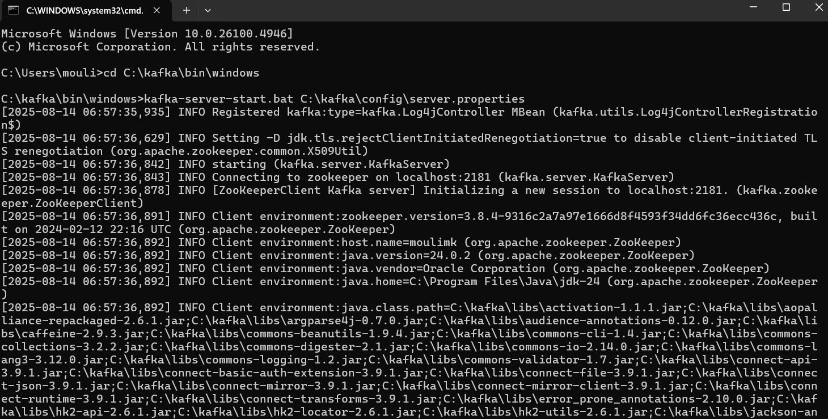

**Starting zookeeper**

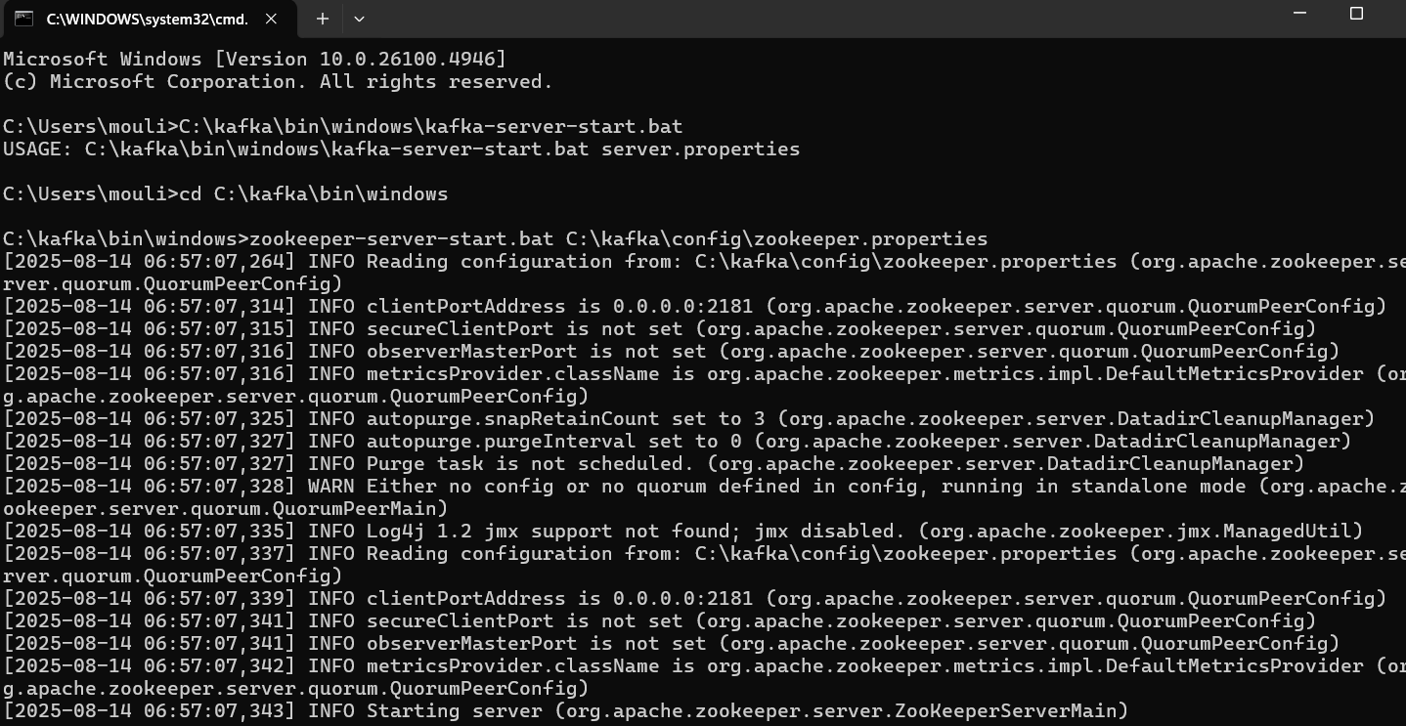

**Chat in console:**

